**Homework 3: Design Principles**

Edward Tufte is considered a pioneer in the Data Visualization field and you have probably noticed that he is referenced often in your readings so far.

Please read the assignment for this week and then focus on the design principles of Tufte. Read the description (in detail) of these principles

* Find a visualization that you think demonstrates Tufte’s 7 principles. The resources I provide online via the PRIMER text will help you find for this.
* Describe how the visualization demonstrates at least two of his principles. In your descriptions, please quote and/or refer to other readings you use. These readings can be our assigned readings or other references that you have found. Do not exceed one page for this part.
* Turn your assignment in to the link associated with this homework AND post your single page (or less) description on the discussion board associated with this assignment. This single page will be turned into me directly via the link AND also pasted in as a discussion board post!
* Respond to at least two other student’s posts and share an additional critique of the data visualization

Answer:

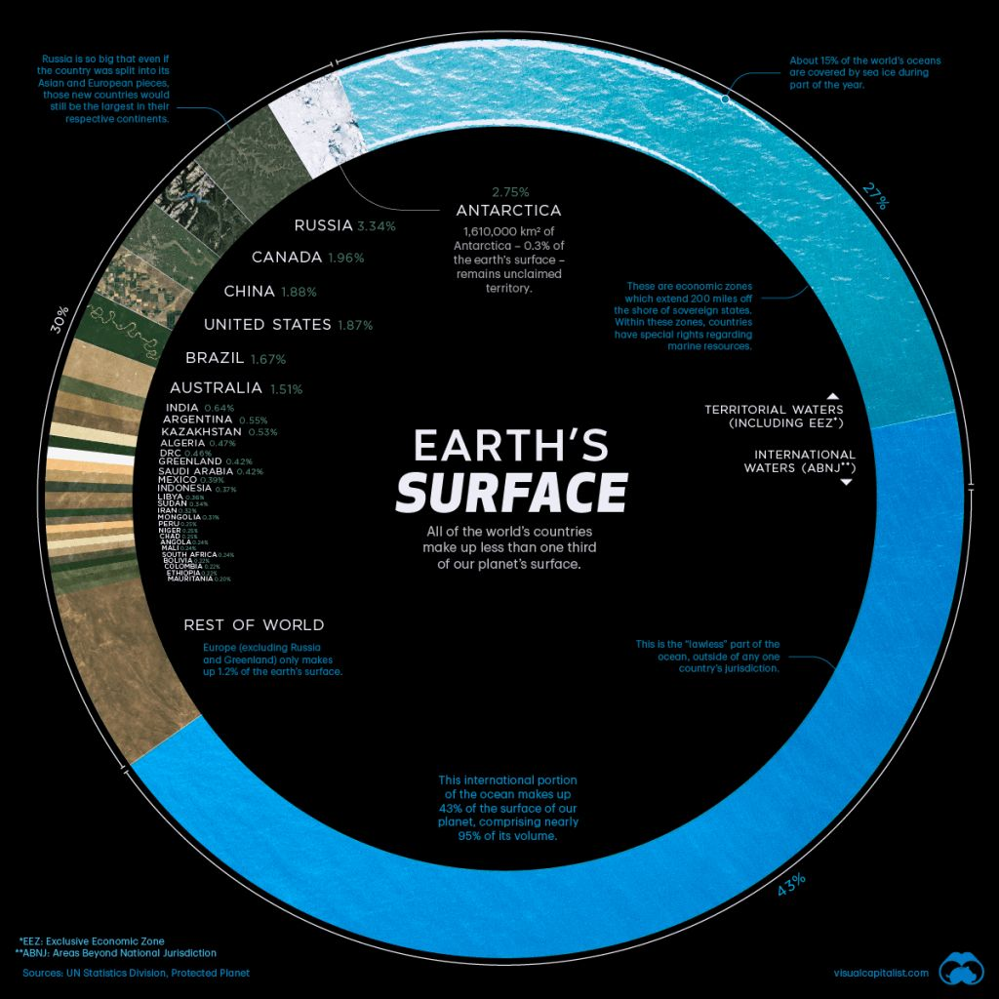

This is a beautiful donut chart of the Earth’s surface. The visualization was obtained from <https://www.visualcapitalist.com/countries-by-share-of-earths-surface/>.

Applying Tufte’s principles of design to the chart, I can comment that for Principle 1 Although black background is usually not desired, in this case it provides a good contrast for the water and land sections (blue and green/brown respectively). Additionally, Principles 5, 6 and 7 were present.

For P5, the graph is designed to provide both an overview and a detailed version of the dataset, i.e., A user can quickly grasp that the majority of Earth is encompassed of water (2/3) and at the same time review the distribution of land with respect to countries.

For P6, I suspect the donut chart was not the first attempt. Maybe a classical pie chart was explored first but it has the shortcoming of not having a good place to present the text and notes explaining the dataset. Additionally, a bar chart or other visualization could have been use but the round shape of the donut chart plays well with the fact that we are talking about Earth (sphere).

In P7, space is present very subtly in the water section where it has a drawing representing ice. The legend “Over 15% of the world’s oceans are covered by sea ice during part of the year” points exactly to this section.

In conclusion, this is an interesting visualization because it is a good fit for a circular (donut) chart and it also follows several Tufte’s Principles in order to communicate interesting facts and dataset to the audience.